Understanding communication in the workplace

Purpose
To develop knowledge and understanding of the communication process in the workplace as required by practising or potential first-time line managers.
To improve your own communication skills!
To build your personal toolkit of effective communication “tools” to build more effective work relationships

Learning Outcomes
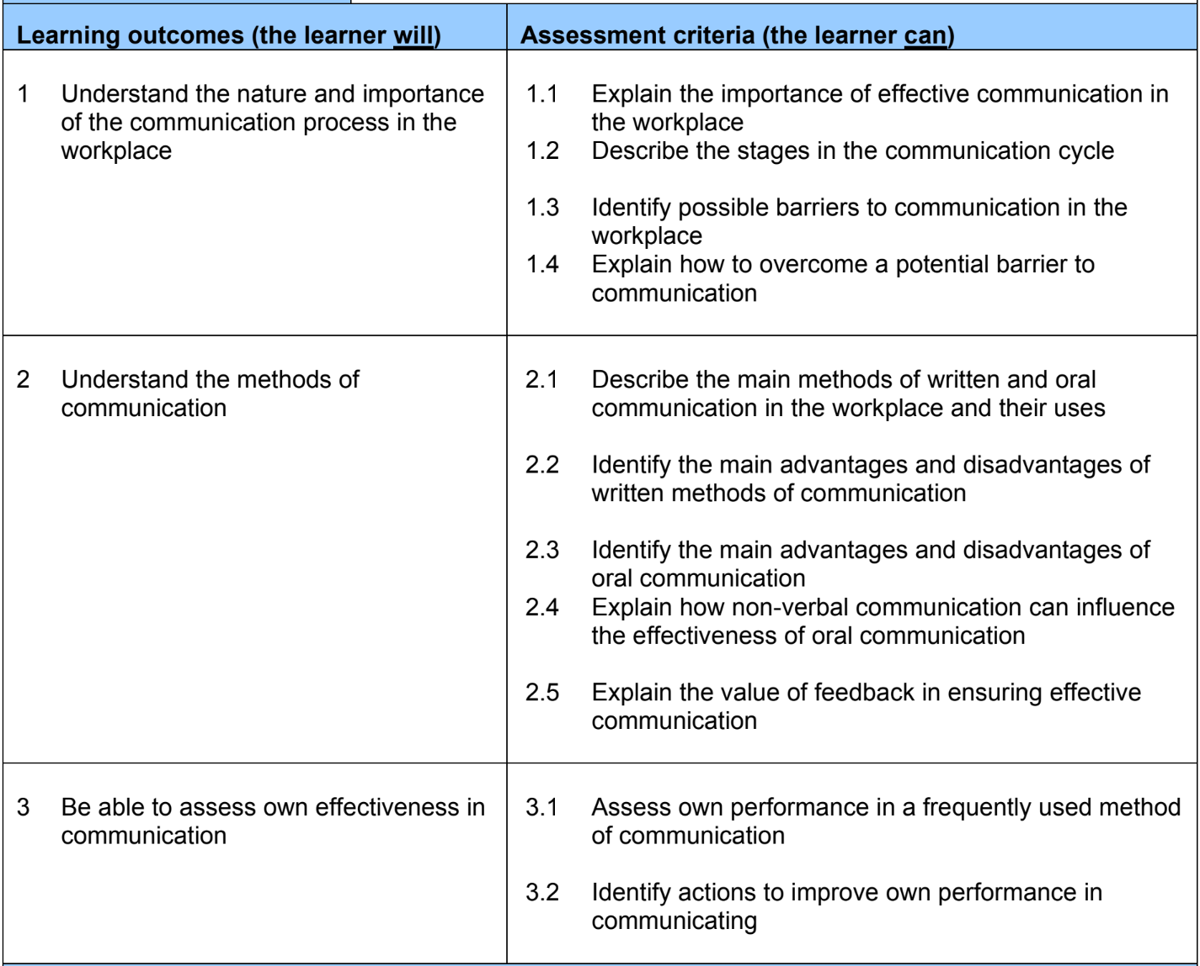

Contents
Purpose 2
Learning Outcomes 2
What is communication? 4
Why is Effective Communication So Important? 5
The Cs of Communication 6
The stages of communication 7
Barriers to communication 8
Examples of Barriers to Communication 8
How to overcome barriers 9
Methods of Communication 10
Written 10
Oral/Verbal 10
Generational Preferences in Communication Method 11
Activity: Your chosen method of communication 12
Nonverbal Communication and Body Language 13
Activity: How you use your body language 15
Active Listening Skills 15
Activity: Listening Skills 17
Feedback 17
How to give effective feedback 18
How to receive feedback 20
How feedback ensures effective communication 21
Evaluate your communication efficacy 21
Activity: Self-awareness 22
Johari Window 22
Activity: Johari Window 23
Resilience 24
Pillars of resilience 25
Activity: Build your resilience 26
Putting it all together 26
Activity: How you effectively communicated 26
Activity: How you can improve your communication 27
Further Information 27

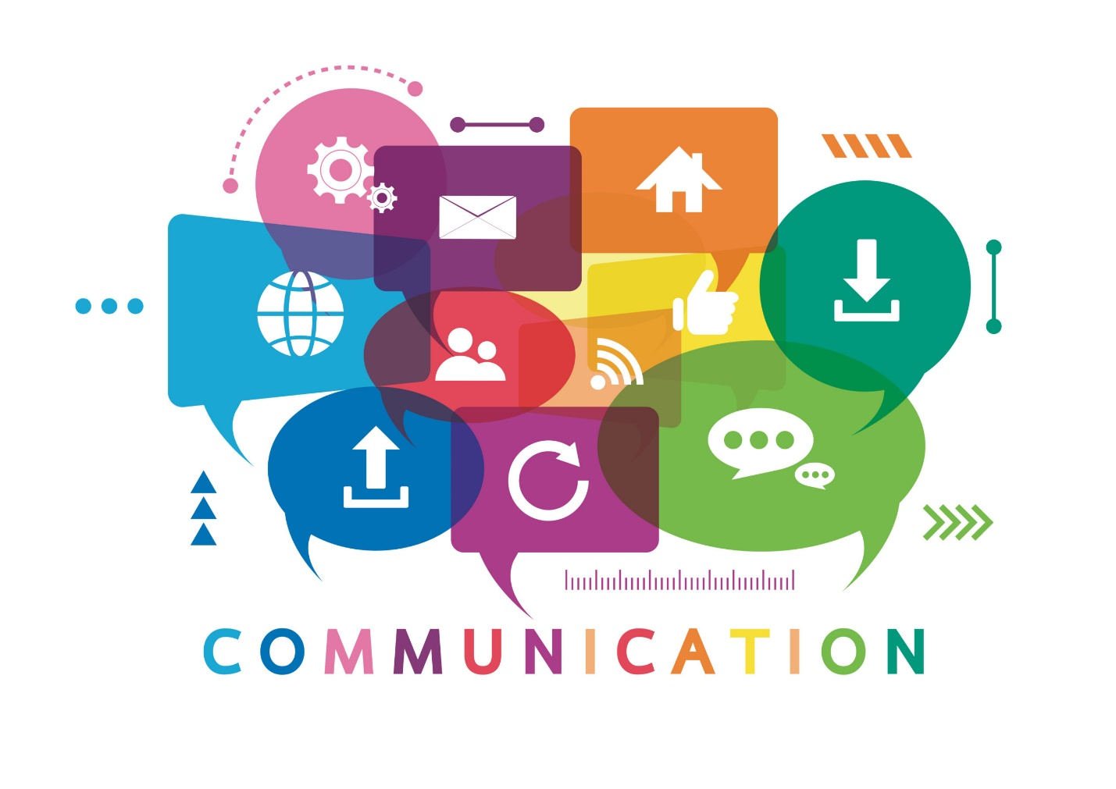
Image from: https://careers-in-sport.co.uk/wp-content/uploads/2020/05/Communication--scaled.jpg

What is Communication?
The Oxford dictionary defines communication as “the imparting or exchanging of information by speaking, writing, or using some other medium.” However, this definition fails to capture the importance of the receiver receiving the communication.
When we say communication, what we are really aiming for is effective communication. This can be defined as, “the process of exchanging ideas, thoughts, opinions, knowledge, and data so that the message is received and understood with clarity and purpose.” (Coursera, 2022)
Overarching points about communication:
- There is both intentional and nonintentional communication
- Communication is always happening
- The meaning is not just in the words
- Communication is not a solution to all problems
Communication is highly studied and for good reason. If we had a formula for perfect communication that results in changed outcomes and behaviour, every leader in the world would be using it. But we don’t. Humans are not formulaic; we are the by-products of social evolution and we have adapted as a society to communicate in different ways over the years. In the last few decades, the speed of information transmission and the number of technological ways we can communicate has rapidly increased. This allows for a lot of information exchange but critically can reduce comprehension and focus required to digest complex messages. Its important to remember that the younger generations have grown up in an age of high volume/ speed information exchange with less practice receiving long/slow/complicated messages.
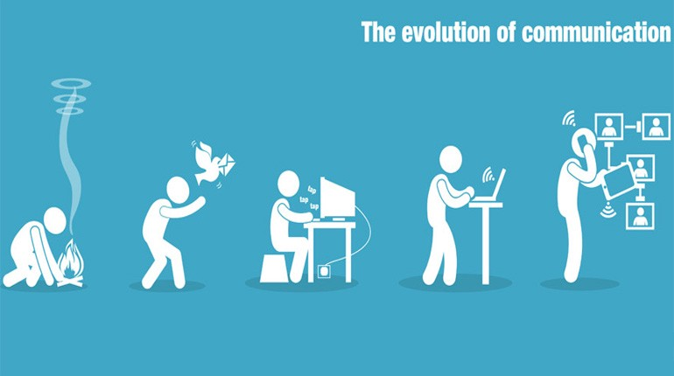
Image from: https://medium.com/@mehtavandan97/how-has-communication-changed-over-the-years-2-a9d529e8f3b6

Why is Effective Communication So Important?
In a nutshell, effective communication is what makes systems work; drives projects to completion and helps people to understand each other. Becoming an effective communicator is essential to leading a team.
- creates a positive work environment
- results in enhanced job satisfaction
- allows for the efficient completion of projects
- builds positive bonds among co-workers
What good communication is NOT
- content sent via a written method that is most suited for verbal communications
- emotional
- unkind
We have all been on the receiving end of someone who is having a bad day or who is struggling to communicate about a difficult issue. It’s important to be in touch with one’s own emotions so they aren’t allowed to get tangled up with our attempts at effective communication.
Mark Bowden studies human behaviour and its impact on communication and trains people on how to communicate more effectively.
Mark Bowden https://www.youtube.com/watch?v=4NxyePJazyE

The Cs of Communication
- Clear
  - The words chosen are representative of the message.
  - The voice is audible.
  - The writing is legible.
  - Colloquialisms and slang only used if appropriate to linguistic and cultural situation.
  - Ensure no room for misunderstanding.
- Correct
  - Ensure facts are accurate.
  - Double check language and grammar before sending written messages.
- Complete
  - Provide the full story. Empowering others with information increases understanding and trust.
- Concise
  - Transmit the message in as simple language as possible. If the recipient must work hard to receive the information, its likely to get lost or be coded to memory as fuzzy or incomplete.
- Compassionate / Courteous
  - Try to understand the other person. Listen carefully. Be respectful. Put your assumptions aside. When a person feels like they're being heard, they will be more open and feel safe to be honest with you.
- Curious
  - Really try to understand what motivates the other person/people. How will they feel about your communication? If they don’t seem to be receiving it well or at all, what questions can you ask to understand their perspective and find common ground.
- Cohesive/ Connected
  - Think about your message before you speak or hit send. Also ask yourself, “what do I want the other person to get from this message?” and focus the communications on that point.
During communication, the ideas and opinions of two people are brought together through words. The decoding stage, noted in the communication stages below, is where the recipient has the chance to make meaning, in their own mind, of what the sender communicated. The image above shows how two different perspectives can take the same message and see it in a different way.

The Stages of Communication
- Create the message: The sender creates (thinks of) a message intended for a specific audience: person or team.
- Encoding the Message: The sender thinks of words in the mind or types/writes message out to be sent.
- Select channel: Sender considers how best to deliver the message. Is this channel the best way to communicate this message? Is this the best time to send this message?
- Decoding Stage: The recipient takes in the message (by listening or reading)
- Meaning Stage: The recipient integrates the message into his/her perspective and decides what it means and, if a response is needed, how and when to respond.
- Feedback stage: Feedback helps both sides know if they have reached a mutual understanding. It may be a time for asking further questions, using appropriate body language ques or active listening indicators. Summarising at the end ensures the sender, that the recipient has received the intended message.
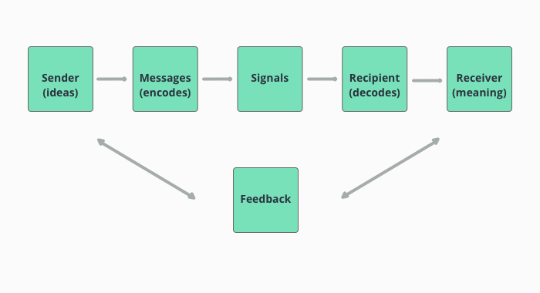
Image from https://www.userlike.com/en/blog/communication-process

The meaning stage is the point at which the recipient understands (or doesn’t) and agrees/ complies with (or doesn’t!) the message. It is this stage at which a misunderstanding may occur. Note that perspective is often the origin of misunderstanding. Other sources of misunderstanding can derive from how the sender crafted the message or how he/she delivered it. Let’s explore further barriers to communication …

Barriers to Communication
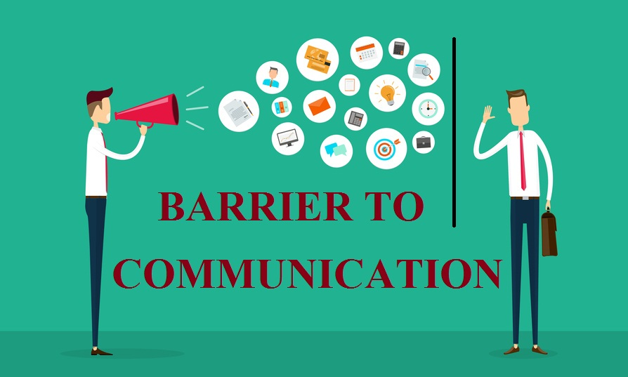
Image from https://1.bp.blogspot.com/-8GbEpN41EL0/X5MReC9VzHI/AAAAAAAANk8/Lh1OIgsz2M452GQcIqV-u9yUTix5YdU3QCLcBGAsYHQ/s894/Barrier-To-Communication.jpg
Barriers are factors which distort or prevent effective communication.
Barriers to good communication can be physical, emotional or linguistic, in nature.
Physical: especially in a food manufacturing site or on a farm, sometimes the team is spread out and with limited or no access to reliable technology/ cell phone service, etc. A recent example we all have experienced is the plastic barriers placed between us in most shops and public buildings during COVID.
Emotional: If team members are anxious, worried or don’t have a strong sense of belonging in their team, they may be unable to speak freely. Fear of conflict may also prevent open, honest discussion.
Linguistic: These are ques used to convey a message such as written, verbal or body language indicators that the recipient doesn’t understand. This is especially relevant when communicating with people who speak a different language or are from a different culture.

Examples of Barriers to Communication
- Information overload: Especially if the message is new to the recipient (new hire or being trained) offering too much information can turn off the brain and ears of the recipient. Focus on the central message first.
- Technical jargon or terminology: Although some jargon may be unavoidable, too much can prevent clarity for the recipient, if they don’t understand the terminology. Avoid using acronyms and instead try to give the message in plain, understandable language.
- Language barriers: If the communicators don’t share a common language or culture, there can be phrases or expressions that cause misunderstandings. One culture may consider eye contact to be a sign of listening while another may interpret this as aggression.
- Different natural ways of communication: Experiences, personality, training, self-awareness all contribute to a person’s nature of communicating.
- Physical disability: hearing or visual impairments, speech impediments or other disabilities can make it harder to receive or convey messages. Educating the team about how disabilities impact communication can help to overcome this barrier.
- Poor listening skills: We live in an era of phones and ever-present screens. Try to be patient and maintain focus on the communicator. Disinterest or detachment from the task at hand can contribute to poor listening skills.

How to Overcome Barriers
- Be present. Concentrate on what the person is saying with their language and body language. Allow them to speak without interrupting.
- Reflect on your own communication, during and after the communication. Use self-awareness to improve yourself.
- Consider if the communication medium is correct for the message. Some messages may be best suited for email or others in person.
- Know what you’re trying to say so you choose clear, concise words.
- Be direct. Try to remove words like, “um, like,” and “ah” and phrases such as, “I think that”. They don’t add value to your message and distract from the main message.
- Encourage questions. Stay curious about the other person’s perspective. Genuinely understanding each other is how you arrive at a cohesive plan, as a team.
- Ask questions. This helps to ensure you both understand.
- Be respectful of the other person’s communication style and method.
- Be cheerful and optimistic.

Methods of Communication

Written
Email, text, post, notice boards
Uses: Written communication is best used when you need to convey a set of instructions, a plan of action, a schedule or anything of complicated or critical nature which the recipient may benefit from reading and may need to refer to again.
Advantages
- Best for content which is longer or more complicated.
- Sometimes it’s the only option available if you cannot speak to them via phone or in person.
- It ensures a message is documented and thus is proof of communication.
Disadvantages
- More time consuming than verbal communication.
- In some cases, can increase misunderstanding because there isn’t a way to have instant follow up conversation.
- Can be shared with unintended recipients.
Tip: If you find yourself hesitating to send a message or email because you’re worried about how it will be received, that might be an indicator that it’s information that may be best suited to be communicated verbally.

Oral/Verbal
In person, telephone, video call
Uses
Best used when opinions and discussion are required, when trying to reach an agreement or solution to a challenge. Best method of providing and receiving feedback and having a broad conversation about issues or topics in the workplace.

Advantages
- Saves time because it doesn’t need to be written, typed and sent.
- Allows for a personal more intimate conversation which may be preferable depending on what needs to be discussed.
- Allows for immediate feedback/ dialogue which may eliminate time waste or misunderstanding.
- Misunderstandings and concerns can be clarified on the spot.
- Allows for greater flexibility because the conversation is created in the moment and can change direction depending on circumstances.
- Builds rapport and empathy or each other.
Disadvantages
- Oral communications are limited in that you cannot produce a diagram or drawing like you can in written communication.
- May not be appropriate for some complex or lengthy content which requires the recipient to read and digest the information.
- Doesn’t allow for record keeping as might be required for human resource conversations or legal items.
- Due to the fact of added body language, in the case of in person conversation, the meaning can be received differently. In other words, body language can either enhance or detract for understanding depending on its use.

Generational Preferences in Communication Method
It’s valuable to note that as we evolve our methods of communication, it leaves certain generations more likely to prefer certain methods of communication. While this is not scientific, its worth considering as you look at your team and how they may each prefer to communicate.
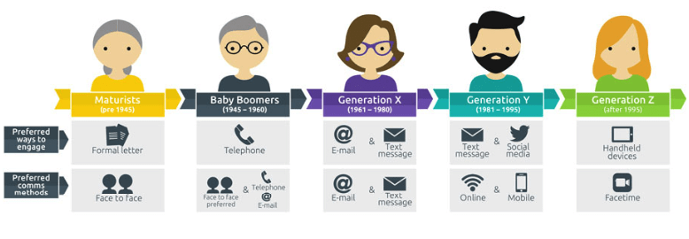
Image and more information from: https://visitjeromeidaho.com/2021/01/bridging-the-generational-communication-barrier/

Activity: Your chosen method of communication
Your preferred method of communication:

………………………………………………………………………………………………………………………………

Why are you most comfortable in this method? How do you excel in this method?

………………………………………………………………………………………………………………………………..

.……………………………………………………………………………………………………………………………

………………………………………………………………………………………………………………………………..

What is hard for you about other methods of communication?
.………………………………………………………………………………………………………………………………

………………………………………………………………………………………………………………………………..

List 3 things you can do to help develop yourself in using the methods that are most difficult for you.
.………………………………………………………………………………………………………………………………

………………………………………………………………………………………………………………………………..

Nonverbal Communication and Body Language
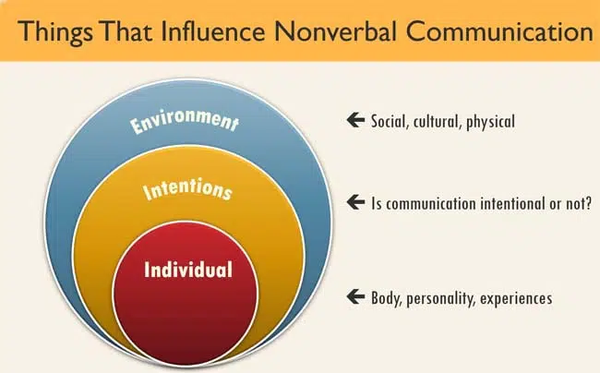
Image from: https://symondsresearch.com/influences-body-language/
Nonverbal communication is indicators we send about our feelings and emotions through facial expressions, gestures and body postures, emphasis and intonations on some words, and the distance between the sender and receiver.
These indicators are being sent all the time that we are in the physical presence of others, and they can be either intentional or unintentional. Different cultures and workplaces offer guidelines for how to communicate nonverbally.
Unintentional body language may be facial expressions or body posture that responds to positive or negative messages without our being aware of it.
The goal is not to micromanage and pick oneself apart about every eyebrow movement but its critical to be aware of your own mannerisms so that you can maintain a respectful and professional demeanour.
Facial Expressions
Facial expressions are messages we can send that show agreement, concern, doubt, curiosity, eyebrow movements, a smile, frown, etc. Facial expressions have high impact. They can even override what is being said. Therefore, it’s important to be aware of one’s own facial expressions and to pay attention to the expression of those we’re talking to.
Posture and Position
How you position yourself during a conversation is important. If you are facing the other person with a relaxed and inviting stance, you encourage the other person to be more engaged and honest. Equally, leaning away or crossing your arms sends a more aloof tone to the other person.
Gestures and physical touch
A gentle touch on the arm can be a sign of encouragement while a crushing handshake may send an aggressive message. It’s important to understand the culture of the person you’re speaking with and be respectful of their wishes.
Eye contact
Maintaining regular eye contact sends a message of interest and honesty. In some cultures, too much eye contact can be a sign of disrespect but in the west, regular eye contact is valued and seen as a positive factor. It demonstrates that you’re engaged and present.
It is especially important to maintain eye contact during difficult conversations because the sense of honesty and sincerity can soften the impact of the message.
The impact of nonverbal on verbal communication
Nonverbal communication has a huge effect on how the verbal communication is received. It can complement and reinforce or contradict and confuse the verbal message. A key study conducted by a UCLA professor, Dr Albert Mehrabian shows that listeners feel positively or negatively about a speaker mostly through their body language and vocal intonation.
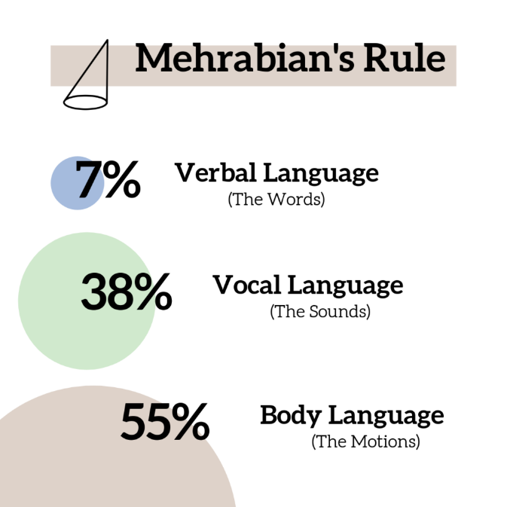  Image from: https://collaborativejourneys.com/non-verbal-communications-virtual-contexts/ | - 7% Spoken words  - 38% Tone, Voice  - 55% Body Language, Gestures  Key Message:  As much as 93% of our emotive response is NOT about the actual words being spoken but about everything else the speaker is transmitting through body language and the sound of their voice.  Remember this when you’re speaking with others. Pay attention to the sound and volume of your voice as well as your body language in your communications.

Make Body Language your Superpower https://www.youtube.com/watch?v=cFLjudWTuGQ

Activity: How you use your body language
Discuss how you use your own body language during communication. How aware of your own body language are you during communication?

………………………………………………………………………………………………………………………………

………………………………………………………………………………………………………………………………..

Envision asking colleagues about your body language during communication. What would they say? What would they offer as ways to improve?
.……………………………………………………………………………………………………………………………

………………………………………………………………………………………………………………………………..

.………………………………………………………………………………………………………………………………

………………………………………………………………………………………………………………………………..

Active Listening Skills
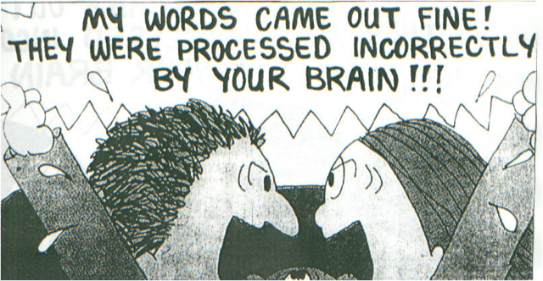
Image from: https://familybusinessperformance.com/what-not-to-do-give-in-to-family-history-of-miscommunication/
Active listening is often overlooked when discussing effective communication, but it is a critical component. When you demonstrate attentive, caring listening, it is clear to the speaker that you genuinely wish to understand them and their concerns, thus building rapport. Positive rapport is the foundation upon which all good collaboration sits.
Active listening is focusing on all the verbal and nonverbal ques from the speaker with the intention of understanding the message.
The active listener
has a clear goal in mind: to capture and reflect both the emotional experience and the ideological perspective of the speaker (Rogers & Roethlisberger, 1991)
Example of absent listening skills: https://www.youtube.com/watch?v=3_dAkDsBQyk
Use the following listening skills to build good will and improve the outcome:
Image from: https://www.ccl.org/articles/leading-effectively-articles/coaching-others-use-active-listening-skills/
Pay Attention: this means staying focused, use attentive body language such as eye contact and not using your phone. Allow the other person to finish without interrupting.
Don’t Judge: Resist the urge to react and offer your opinion. Be open to having your own perspective changed.
Reflect and Rephrase: To ensure you understand, paraphrase what the speaker has just said, back to them. This allows them to amend the information if they’ve misrepresented in speaking or you’ve misunderstood it while listening.
Sender: “John gets his job done well but he never comes to work on time. It sets a bad example to the team.”
Listener: “It sounds like you’re pleased with John’s workmanship, but his tardiness is having a negative impact on the team. Is that right?”
Clarify: This is about asking questions. Ask questions to ensure you’re on the same page.
Summarise: Restating the information or conversation in your own words allows you both to ensure you have heard correctly and for you to add your own comments in from the dialogue.
Share: This is where the listener can offer their own feelings and perspectives on the matter. The level of sharing and content depends on the working environment and relationship.

Activity: Listening Skills
Think of a time when you were communicating with someone who was not listening. In what way did they show poor listening skills? How did this make you feel, as the speaker?
………………………………………………………………………………………………………………………………

………………………………………………………………………………………………………………………………..

.……………………………………………………………………………………………………………………………

………………………………………………………………………………………………………………………………..

.………………………………………………………………………………………………………………………………

………………………………………………………………………………………………………………………………..

Feedback
What is feedback?
Feedback is, essentially, information communicated that may help to improve a situation or deepen understanding. Feedback can refer to several types of communication.
- With regards to the stages of communication, feedback can be the recipient’s response to receiving your message. It may come as an email, a verbal response, a facial expression, or silence. It helps you understand if the message has been understood. Regular, actionable, applicable feedback can have a tremendous impact on professional growth.
- Feedback can be from a manager to an employee about their performance to help them improve and/or to acknowledge great work.
- Feedback may be from a team member to a manager (or another team member) about challenges, frustrations, or suggestions for improvement in the organisation. This may be unsolicited and can provide valuable insights for the manager.
Without feedback, communication is just information. - Agneta Saxeby

How to give Effective Feedback
You may need to give feedback in response to a team member’s behaviour or after being the recipient of communication. Whatever the scenario, learning to give feedback is a critical part of communicating effectively.
Give helpful feedback by being honest, specific, and respectful. Offer the feedback at an appropriate time joined with constructive suggestions.
- Specific: “I’m concerned about your work ethic” v.s. “I’ve noticed that you’ve arrived late three times this week and am concerned about your ability to get the job done when you arrive late.”
- Behaviour: Observed behaviour is the key as its less subjective and easier to help the employee to change. “You cut people off in meetings.” V.s. “I’ve noticed that you begin adding your own voice in during meetings before others are finished speaking. This makes it difficult for everyone to have an equal voice.” Try to show how a behaviour impacts others / the organisation’s goal.
- Impersonal: Focus on the impact of a behaviour and not on the individual employee. This helps the person to feel less attacked and be less likely to respond defensively.
- Goal oriented: Bring the feedback back to the expressed organisational goals. This helps reinforce that you are all on the same team.
- Prioritize: Rather than provide a list of actions or behaviours the employee isn’t doing well or at all, ask for clear change in 1 or 2 areas. A very few explicit changes are easier to execute.
- Timing: Provide constructive criticism individually and soon after the behaviour is noticed so its recent in the memory.
- Ensure understanding: Ask the employee to share with you how they’re feeling about the situation and if they agree to the suggested changes. Explain that this ensures you’re on the same page to avoid the employee feeling patronized.
- Ensure the employee can control it: If the change is outside of the employee’s control, he/she cannot be asked to change it. For example, if traffic is unavoidably bad at certain places or times, be flexible as best you’re able. If its about attitude or work ethic, it’s an area where improvement is possible.
- Constructive: This means offering help and agreeing actionable items to help correct the situation.
- Tailored: Realise that you’re speaking to an individual with different aptitudes, life experiences and preferences to your own and to the rest of the team. Consider these differences in your messaging.
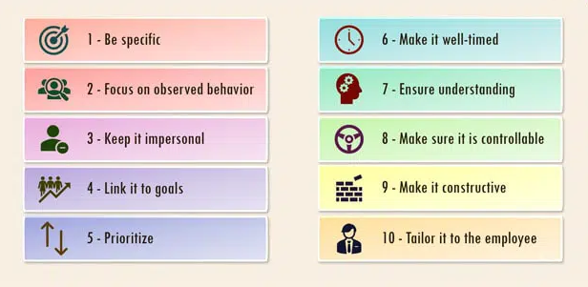Image from: https://symondsresearch.com/principles-effective-feedback/

Kim Scott, author of Radical Candor tells us that,
as leaders, you must give people clear and honest feedback (praise/criticism) for their benefit. The feedback must be given in a manner that helps team members achieve their goals and meet or exceed the high-performance expectations you have clearly defined.
In summary, feedback is essential to effective communication. It sits on a foundation of sincerity. Constructive feedback helps the other person to improve and to better align with the organisation’s goals.

Think of a situation when you have received feedback during a work scenario. Was it given from a manager? A colleague? How did they give the feedback? How did it make you feel? What impact did it have on your actions and behaviour going forward?
………………………………………………………………………………………………………………………………

………………………………………………………………………………………………………………………………..

.……………………………………………………………………………………………………………………………

………………………………………………………………………………………………………………………………..

Putting yourself in the communicator’s shoes, how would you have given yourself this feedback? What would you have done differently?

.………………………………………………………………………………………………………………………………

………………………………………………………………………………………………………………………………..

How to Receive Feedback
As a manager, employee, and colleague, you will receive feedback. Instead of thinking about feedback as a necessary evil, consider it a valuable tool for development. This requires setting your ego aside.
Feedback may come when you’re not expecting it so be ready to activate your effective listening skills.
On other occasions, you may need to ask for feedback. Soliciting feedback is essential to understanding how others perceive your leadership.
- If the feedback is unsolicited and you get the idea someone is going to or is about to give you some feedback, prime yourself to micro-listen. Really home in on what the other person is saying. Ask yourself, “what are the main points I’m hearing?”, “Is this triggering any emotions in me?”, “does the sender seem emotional?”, “How can I summarise what I’m hearing to ensure we’re having the same conversation?”
- When the feedback seems complete, use all the micro-listening to summarise what the sender has said to ensure you are on the same page.
- Acknowledge the sender’s effort. It can take real courage for some to offer feedback and even negative feedback offers insights. Thanking the person for taking the time to provide the feedback may help to create a sense of common ground when the sender may have been expecting to meet defensiveness.
- If the feedback was not clear, the next step would be to try to understand the main points of the message through further conversation.
Key points about soliciting and receiving feedback
Receiving negative feedback does not make you an inferior person or bad employee! It is an opportunity for growth. Even if the feedback is unfounded and about different perspectives, it offers a) practice receiving feedback and b) insights about the sender’s mindset.
Feedback stems from personal perception. We all walk around in our own perspectives, and this makes effective communication tremendously important. Learning to accept differences of opinion, whilst taking on board possible areas for improvement is the key to personal development.
People already have perceptions of you and the workplace. Avoiding feedback simply means you never get the chance to have and use the information to improve yourself and what you can around you.

How Feedback Ensures Effective Communication
Feedback is …
the primary component in the communication process because it gives the sender the opportunity to analyse the effect of the message. It helps the sender ensure that the recipient has interpreted the message correctly. - Agneta Saxeby
In short, without feedback it is not possible to ensure that the sender and receiver are on the same page.

Evaluate Your Communication Efficacy
As with developing leadership skills (and indeed any form off self-development) self-awareness is at the core of improving your communication skills.
The most important conversations you’ll ever have are the ones you’ll have with yourself. — David Goggins
What does this mean? Powerful leadership and effective communication come from people who first understand and know themselves. They know that they do not know everything, that they are will always be learning and developing. Their communications stem from a place of clarity and purpose. Their practice of self-awareness enables them to be observant and curious about what motivates others.
“If you are self-aware, it means you have made (and are constantly updating) an accurate appraisal of your personality, of what motivates you, and what your strengths and weaknesses are. Without self-awareness, your effectiveness will always be limited.” (institutelm, n.d.)
Make self-awareness an important part of your self-development plan. How will you regularly practice self-awareness and become a more effective communicator?
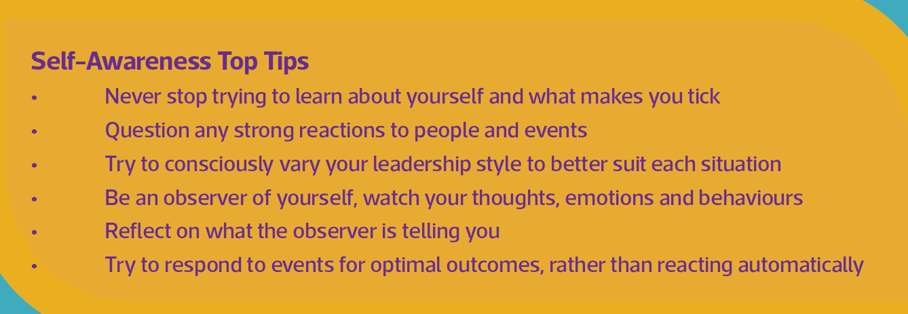
Image source: https://www.institutelm.com/learning/leadership-framework/authenticity/self-awareness/leadership-essentials-self-awareness.html
Self-awareness begins with the recognition that you can always grow and improve. Be humble; recognise that all humans have blind spots – areas of our being that we struggle to see as flawed or as amazing as others might see us.

Activity: Self-awareness
List 3 actionable things that you can do to improve your own self-awareness.
………………………………………………………………………………………………………………………………

………………………………………………………………………………………………………………………………..

.………………………………………………………………………………………………………………………………

………………………………………………………………………………………………………………………………..

.………………………………………………………………………………………………………………………………

………………………………………………………………………………………………………………………………..

Johari Window
Consider this diagram to think about the ways in which a) we all have blind spots, b) others see things about us that we don’t, and c) there is more to discover about our own abilities.
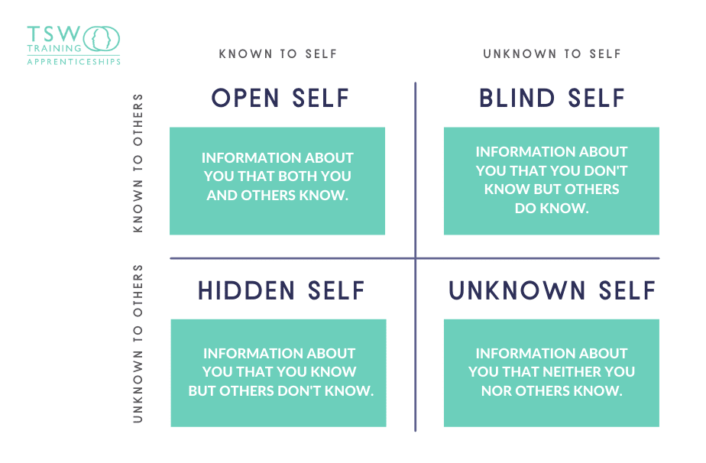
Image from: https://www.tsw.co.uk/blog/leadership-and-management/the-johari-window/
The Johari Window can be used to list adjectives or descriptors about you and your communication skills. In a team setting, you could ask others to write adjectives about you to discover areas they may see but you don’t (Blind Self)

Activity: Johari Window
Activity: Using the definitions of each square from above, write some descriptors or things you know about your own communication in each area. You can ask colleagues to offer feedback for the Blind Spot area and write aspirational aims in the Unknown Self square.
Open Self | Blind Self
Hidden Self | Unknown Self

What steps can you take to learn more about your undiscovered skills in the Unknown Self box?
………………………………………………………………………………………………………………………………

………………………………………………………………………………………………………………………………..

.………………………………………………………………………………………………………………………………

………………………………………………………………………………………………………………………………..

For more information about how you could use the Johari Window as a growth exercise for the team, read more here: https://www.tsw.co.uk/blog/leadership-and-management/the-johari-window/.

Resilience
A discussion of communication would not be complete without reference to resilience. This is because communication inherently offers the possibility of conflict and uncomfortable scenarios or emotions. Resiliency gives us the skills to move forward despite adversity. And let’s face it: you’re guaranteed to meet adversity, in whatever form, at some point.

re·​sil·​ience
an ability to recover from or adjust easily to misfortune or change
-Merriam Webster Dictionary

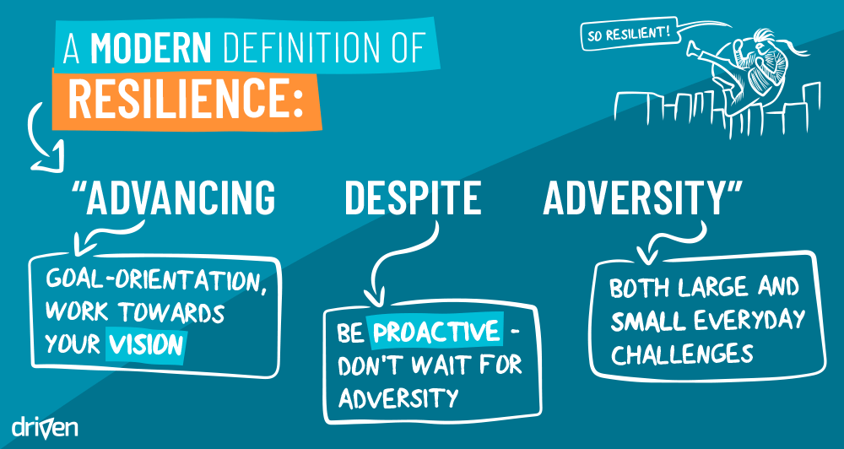
Image from: https://home.hellodriven.com/articles/what-is-resilience-modernising-the-definition-of-resilience/
Consider the following areas of resilience and think about how you can apply them to your own life to enhance your resiliency. Do you think simply sharing this information with your team could help them consider their own resilience?

Pillars of Resilience
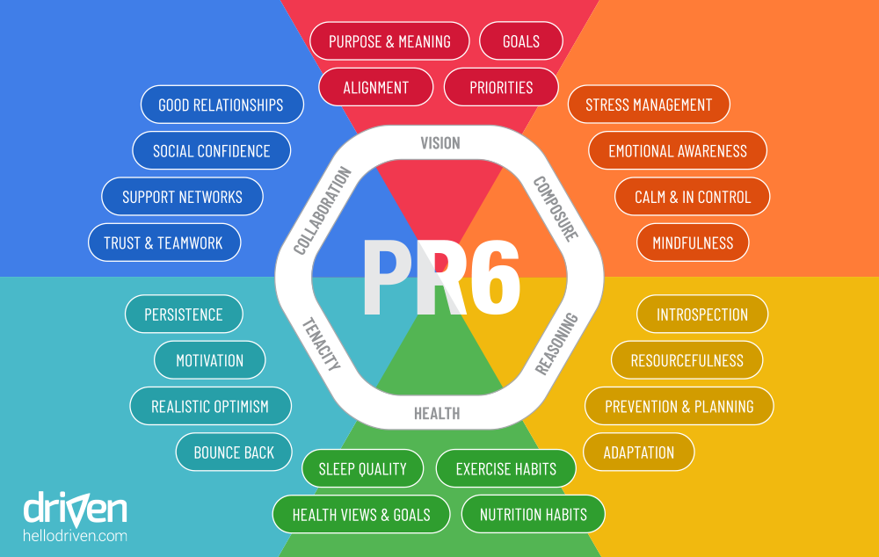
Image from: https://home.hellodriven.com/articles/6-domains-of-resilience/
Vision: your sense of purpose, what drives you, clarity of direction, helps you to be decisive when making hard choices, remove all sources of distraction that aren’t adding value to your vision and purpose
Composure: manage your emotions, save your big energy for important movements, let the small frustrations go without getting upset, commit to assuming all is well, reject natural human inclination towards assuming the worst, prepare for the worstassume the best
Reasoning: use creativity to problem solve, use preventative action where possible to avoid calamity, surround yourself with the right tools and techniques to succeed, consider that the best method might require radical change
Tenacity: Be persistent!, learn from mistakes, don’t dwell on them, find your sense of realistic optimism!
Collaboration: Find and grow your community to support others and to help support you, understand the context of each social scenario. At work focus on facts and goals but use emotional intelligence to gauge what others need.
Health: Make this a priority. Eat healthy goods, try to be active and get quality sleep.

Activity: Build your resilience
Review the pillars of resilience. List at least 3 actions you can take to practice building greater resilience.

………………………………………………………………………………………………………………………………

………………………………………………………………………………………………………………………………..

.……………………………………………………………………………………………………………………………

………………………………………………………………………………………………………………………………..

.………………………………………………………………………………………………………………………………

………………………………………………………………………………………………………………………………..

Putting it all together
This workbook has provided the C’s of Communication to help guide you in constructing your words, its mapped the stages of the communication cycle and listed some barriers to communication. Both verbal and written communication were covered, as well as nonverbal communication. Active listening skills and constructive feedback were mapped out as key skills in excellent communication. Finally, it demonstrated the critical importance of self-awareness and resilience.
With respect to these key points, consider your own communication. Use the following questions as an exercise to practice self-analysis and improve your communication skills.

Activity: How you effectively communicated
Describe a situation when you felt you communicated effectively. What did you say, what factors did you focus on? How was your communication received? How did you know it was effective? Using various aspects of elements addressed herein, consider how self-perceptions, language, nonverbal communication, and listening influenced the effectiveness of your communication.
………………………………………………………………………………………………………………………………

………………………………………………………………………………………………………………………………..

.………………………………………………………………………………………………………………………………

………………………………………………………………………………………………………………………………..

.………………………………………………………………………………………………………………………………

………………………………………………………………………………………………………………………………..

Activity: How you can improve your communication
Describe a situation where you felt communication ‘fell apart’ or ‘fell short’ of what you were intending or wanting. What happened? Why did the communication fail? Using various aspects of elements addressed herein, consider how self-perceptions, language, nonverbal communication, and listening could have helped you to communicate more effectively. ………………………………………………………………………………………………………………………………

………………………………………………………………………………………………………………………………..

.……………………………………………………………………………………………………………………………

………………………………………………………………………………………………………………………………..

.………………………………………………………………………………………………………………………………

………………………………………………………………………………………………………………………………..

Further Information
Coursera. (2022, August). Retrieved from https://www.coursera.org/articles/communication-effectiveness
coursera. (2022, Aug). https://www.coursera.org/articles/communication-effectiveness.
institutelm. (n.d.). Retrieved from https://www.institutelm.com/learning/leadership-framework/authenticity/self-awareness/leadership-essentials-self-awareness.html
wikipedia. (n.d.). Retrieved from https://en.wikipedia.org/wiki/Albert_Mehrabian
https://home.hellodriven.com/articles/6-domains-of-resilience/
https://www.tsw.co.uk/blog/leadership-and-management/the-johari-window/
https://www.throughlinegroup.com/2013/07/21/the-statistic-communications-experts-keep-getting-wrong/
https://ahdb.org.uk/knowledge-library/agrileader-bitesize#1855109419-collapse-one

